PD LAB

ASSIGNMENT - 1

Name: Raunak Thanawala

Registration Number: 231070051

Branch: Computer Engineering

Batch: 3

**Aim:-**

To Handle Different Versions of Python and their Virtual Environments

**Theory:-**

To install Python on a Linux Operating System we have to:

1. Update Package Lists:

First we have to update package lists to ensure we are getting the latest version of Python available. We do this with the command:

sudo apt update

1. Install Python:

To Install Python on Linux we use the command given below next:

sudo apt install python3

1. Verify the Installation:

To verify that Python is installed, we use the command:

python3 --version

To install multiple versions of python on the same device we can use the same commands but instead of typing:

sudo apt install 3.* where * is a number such as 9 or 12 where 3.9 or 3.12 is a version of python.

Now to use python we need to create a virtual environment of the correct python version which can be done using VSCode:

1. Open VSCode
2. Click View and then Command Palette
3. Then type in Python and select Create Environment
4. Then click Venv
5. Then Click Delete and Recreate
6. Then we select the version of python we want to create the virtual environment for
7. This should install the virtual environment file

**Code and Output:**

for i in range(1,11):

for j in range(1,11):

print(f"{i*j:<3}", end="")

print()

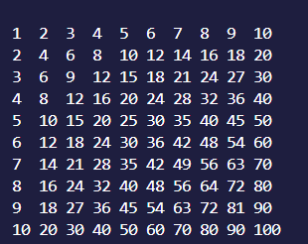

**Installation of Python and Virtual Environment:**

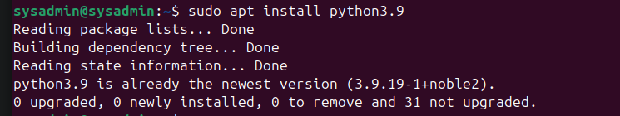

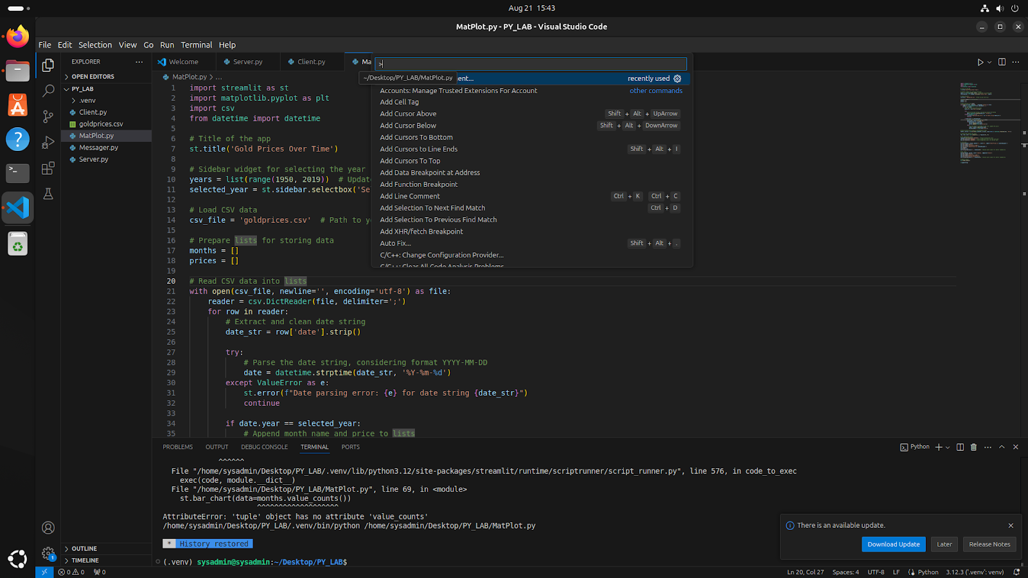

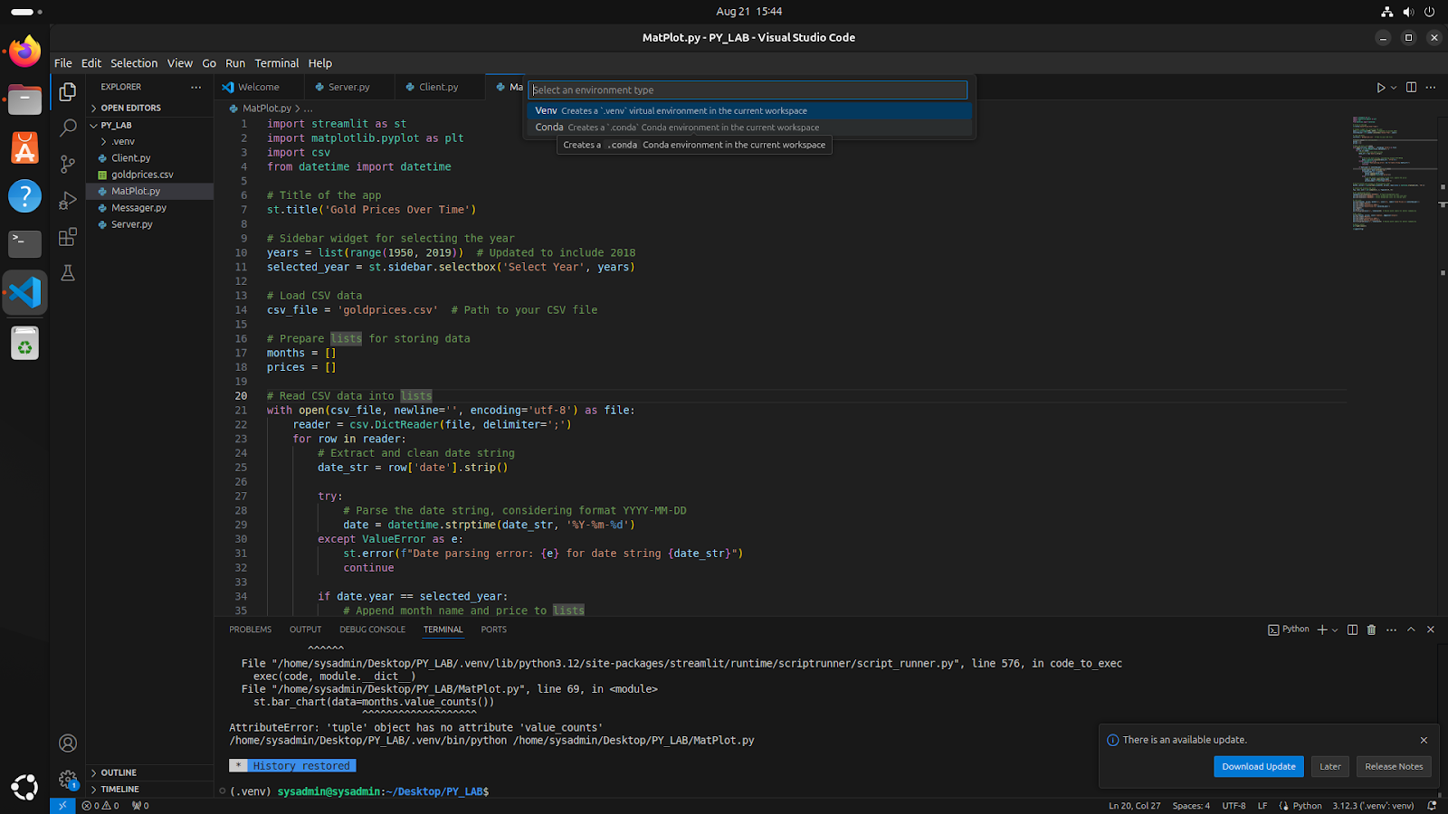

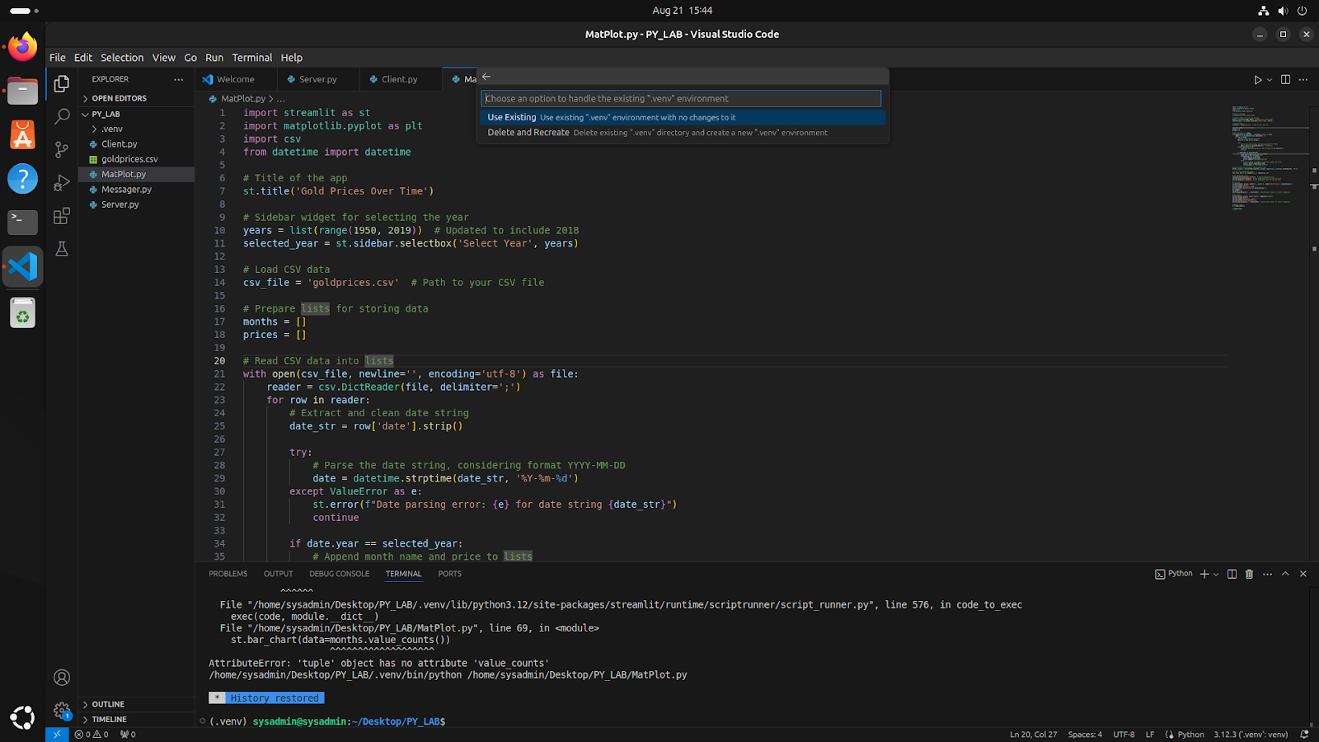

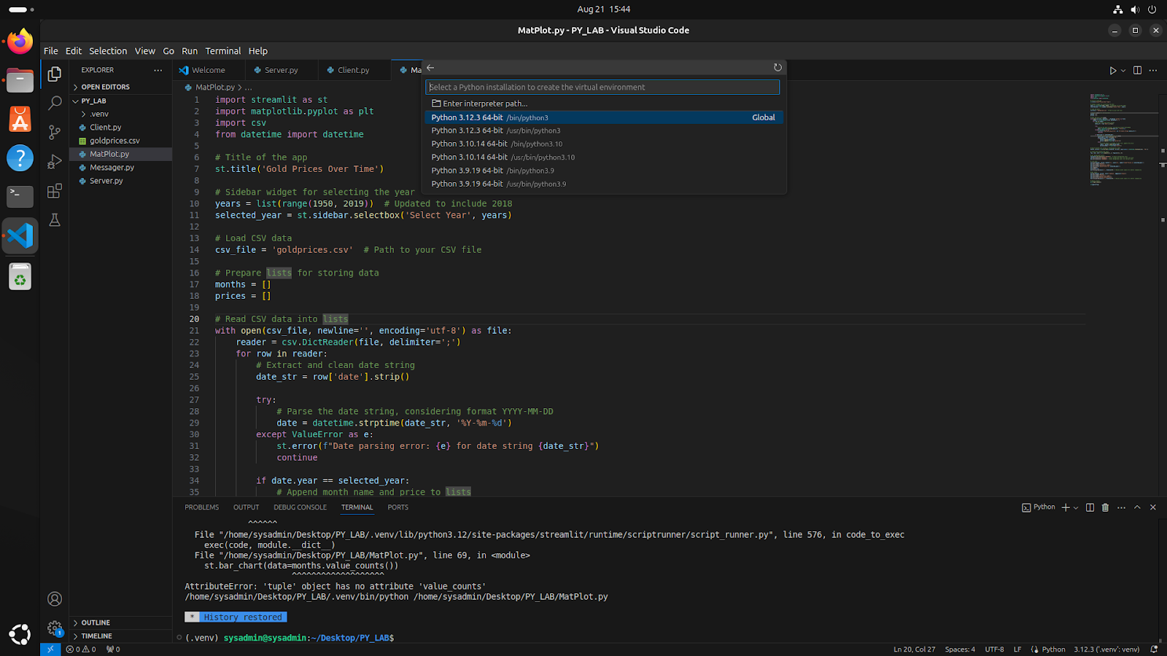

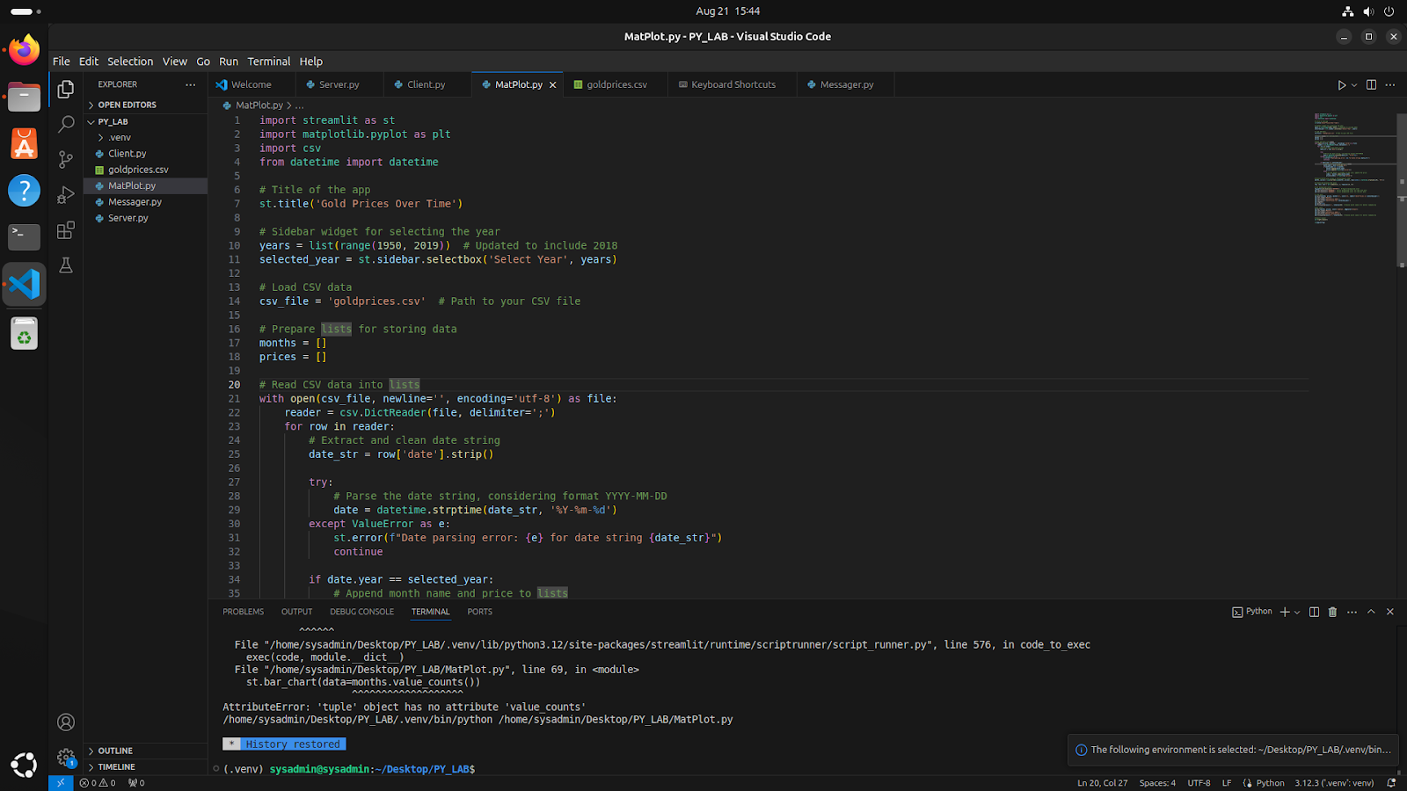



**Conclusion:**

Thus we have written a program to write multiplication tables of 1 to 10 and we have also learnt how to install python on linux terminal and then we also learnt how to create a virtual environment for that version of python using VSCode.